# **Project - Zomato**

**Objective Questions**:

1. What is the total no. of tables present in the data? -

There are 2 numbers of tables present in the data and their names in respective manner: **Raw data**, **Country description.**

1. What is the total no. of attributes present in the data? -

The **Raw Data** table contains **20 attributes** and the **Country description** table contains **2 attributes** .

1. How many categorical columns are there in the data? [Search about categorical and continuous data, and try to answer this question] -

Categorical columns contain discrete values that belong to a limited set of categories and represent qualitative attributes or characteristics.  
**14 categorical columns** are there in this data set below are the categorical column names.  
RestaurantName, CountryCode, City, Address, Locality, LocalityVerbose,Cuisines_Updated, Currency, Has_Table_booking, Has_Online_delivery, Is_delivering_now, Updated_Datekey_Opening, Switch_to_order_menu, Price_range,Country.

1. The data consists of some inconsistent and missing values so ensure that the data used for further analysis is cleaned. -   
     
   Removed the rows which values are missing in the "Cuisines"  
   First Filtered the Cuisines with blanks and selected the blank rows and deleted it

Formatted text Datekey_opening to proper date method using below formula

**=DATE(LEFT(V2,4), MID(V2,6,1), RIGHT(V2,LEN(V2)-SEARCH("_",V2,6)))**

Formatted currency name to symbols mapping with new table named as countryMapping, used below formula  
**=IF(ISBLANK(M2),"₹",VLOOKUP(M2,'Country Mapping'!$A$2:$B$13,2,0))**

1. Using the LookUp functions, fill up the countries in the original data using the country code.

Using Index&Match lookup function created new column as **Countries** in the table and using below formula got the whole country names.

**=INDEX('country description'!$B$2:$B$16,MATCH(C2,'country description'!$A$2:$A$16,0))**

1. Create a table to represent the number of restaurants opened in each country.

Using the Pivot table feature created a table to represent the number of restaurants opened in each country. Taking countries into rows and counting of restaurants as in values. Here is the created table image attached below.

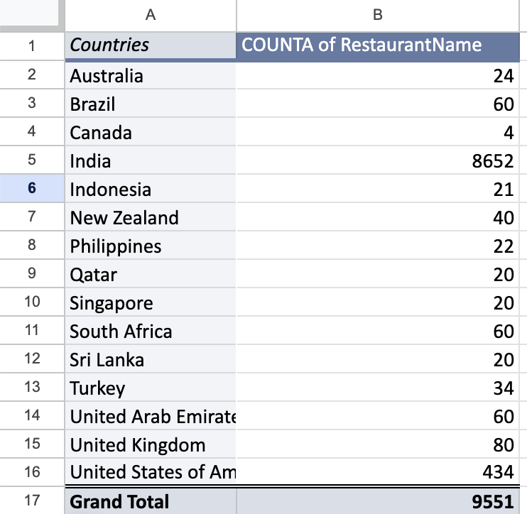

1. Also, the management wants to look at the number of restaurants opened each year, so provide them with something here.

For this I have separated year column from the datekey_opening_imputed column, and using pivot table placing years in rows and count of restaurants in values got to know the number of restaurants opened each year, here is the image

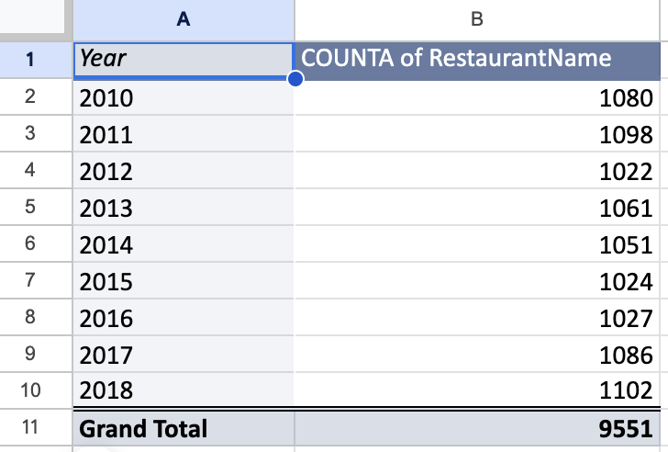

1. What is the total number of restaurants in India in the price range of 4?

**388** restaurants are there in India in the price range of 4

Created a pivot table by taking countries into rows and price range to column and number of restaurants to values,here is the result image  
 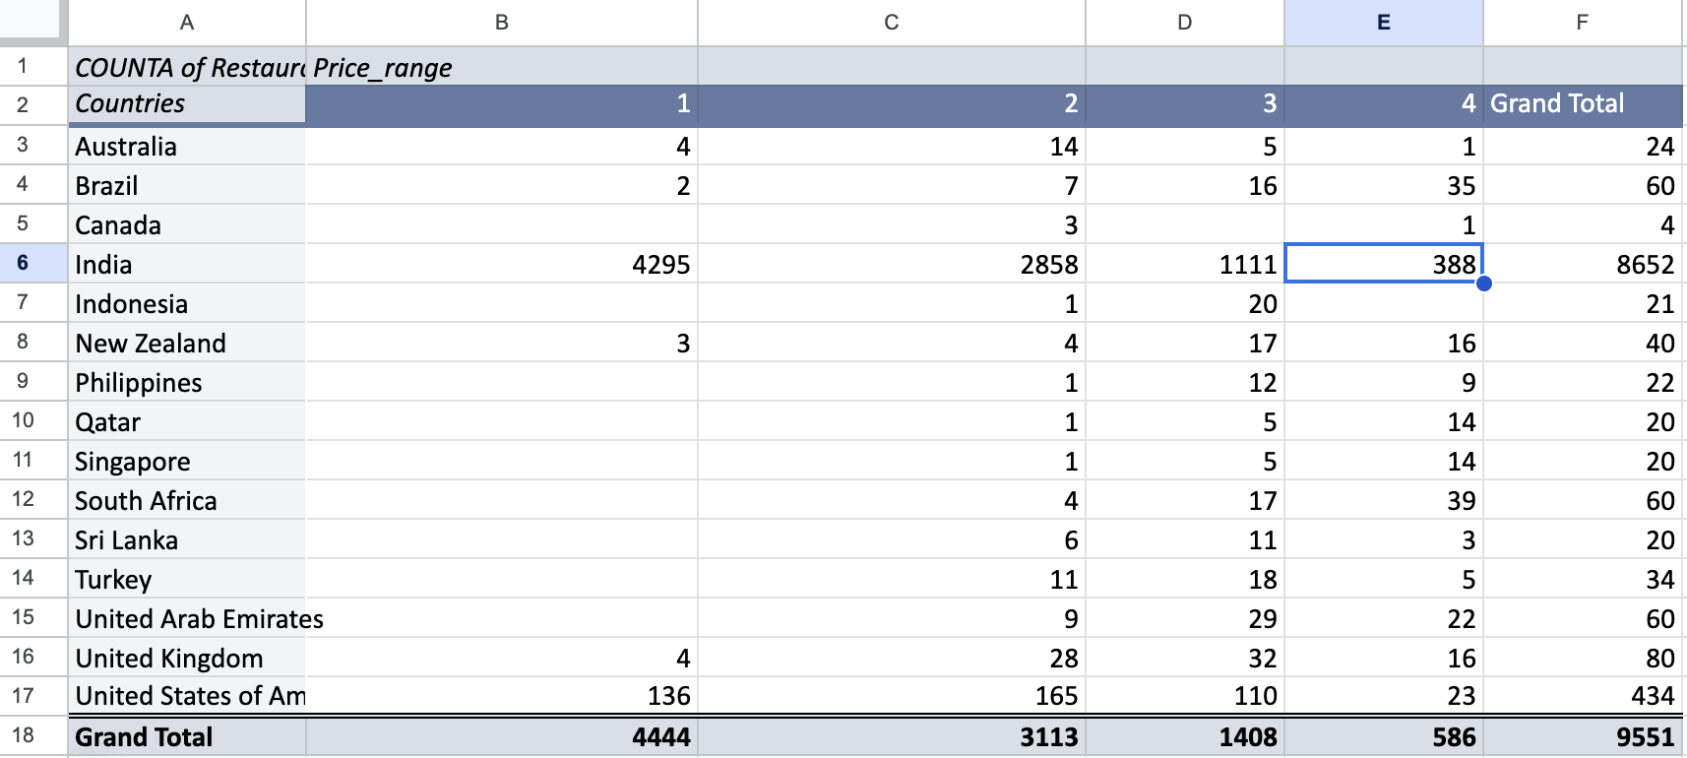

1. What is the average number of voters for the restaurants in each country according to the data?

Explanation:

* Select all cells in the "Raw Data" sheet.
* Go to Insert -> Pivot Table, and specify the location for the pivot table.
* Drag "Country" to the Rows section and "Votes" to the Values section. By default, it will show the sum; change this to average.

Here is the image attaching for average number of voters for the restaurants in each country according to data

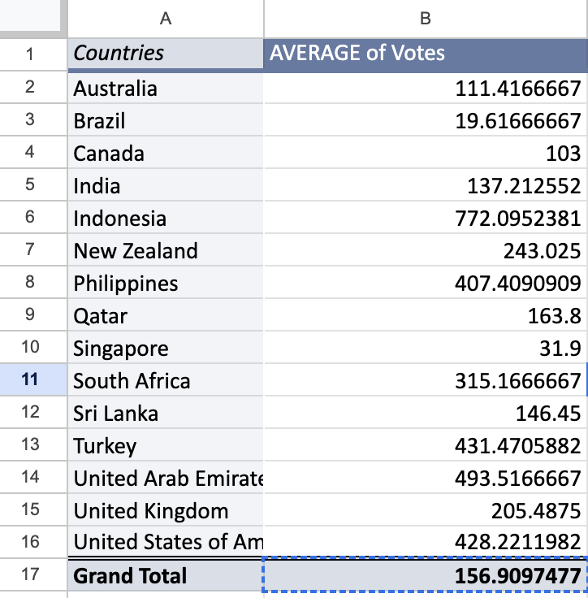

1. Calculate the average rating for all the restaurants that have price_range < 4 and provide online delivery. Use only the “IF” function, Logical Operators, and Aggregation functions to solve this problem. **[Note: Don’t use Conditional aggregation in this question.]**

Ans - To calculate the average rating for restaurants with a price range less than 4 and that offer online delivery, use the IF function along with logical operators and aggregation functions

Explanation

* Using AVERAGE , IF and ARRAYFORMULA
* The formula is **=ARRAYFORMULA(AVERAGE(IF(('Raw Data'!$S:$S<4)*('Raw Data'!$P:$P="Yes"),'Raw Data'!$W:$W)))**
* where S(Price Range) , P(online_delivery) and W(Rating)

**3.28** is the average rating forrestaurants having price range < 4 as well as providing online delivery, achieved this by using below formula

1. Using Conditional formatting highlight the rows of restaurants that are located in the countries or cities that you’ve suggested to the management for opening new restaurants.

**Approach:**

* Use a pivot table to list countries against aggregates of no of restaurants,their average rating and average of average cost for two.
* Identify and remove outliers from all respective columns of countries’s restaurants, India and Unites States are outliers to data.
* Locate the lowest average ratings of all countries’s restaurants.
* Identify the budget(average of average_cost_for_two) that could appeal to any segment,i.e premium or low budgeted individuals.

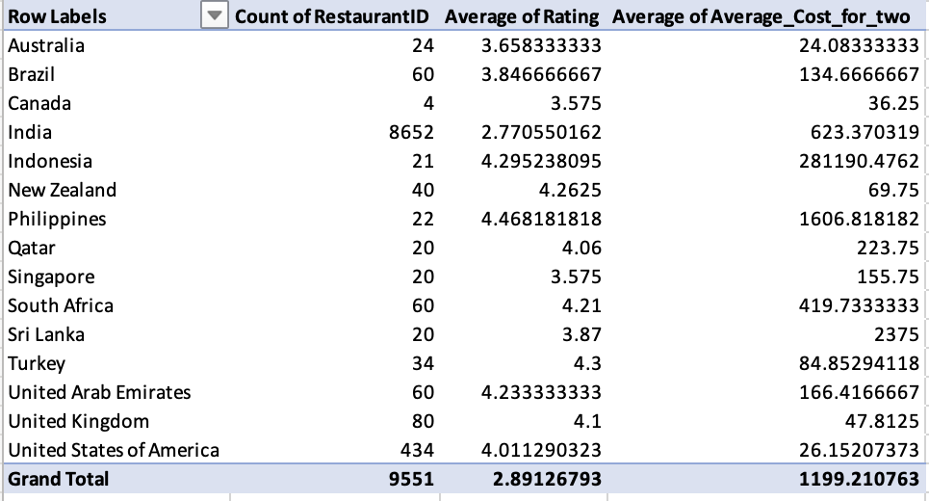

Table with highlighted countries citing lowest average of average_cost_for_two, lowest Number of restaurants, and lowest Average of rating,citing a balance between all these three.

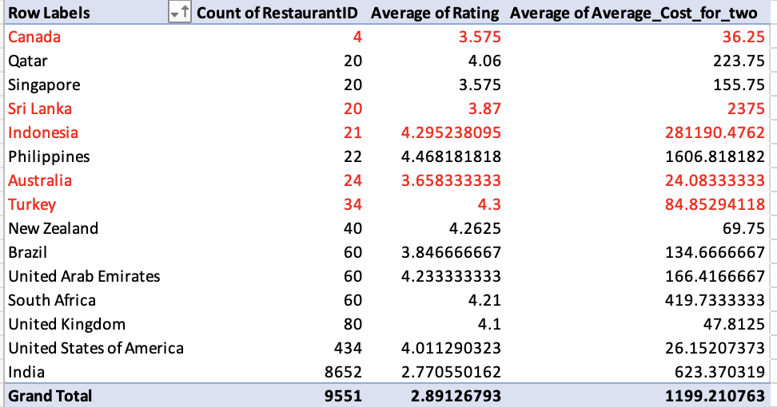

* Countries are:

Canada, Australia, Turkey, Indonesia, Sri Lanka.(highlighted in faint red in above table).

Conditional Formatting: go to “New Rule” button and go to “Use a rule to determine which cells to format” tab and write the below formula for highlighting entire rows with suggested countries

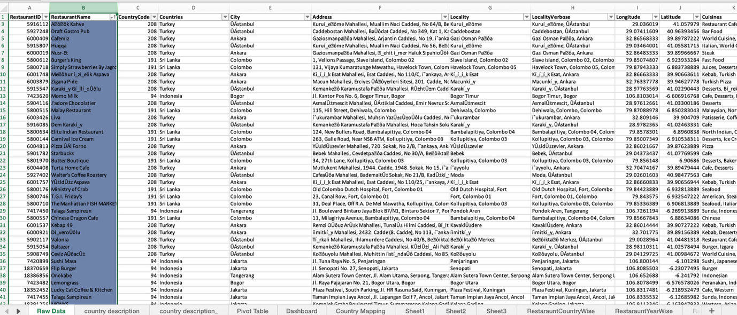

**Criteria for Selecting Suggested Countries:**

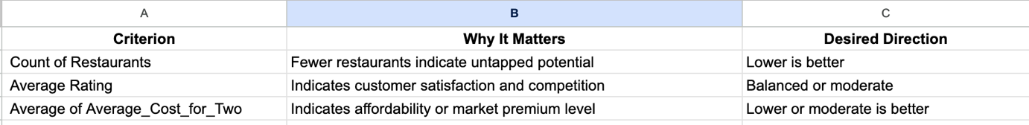

**Insights:**

Countries indicated with balance of least number of restaurants, least average_price of two,least ratings are (Canada, Australia, Turkey, Indonesia, Sri Lanka.) are colored as orange in Raw_data table.

1. Create a new customized price column that consists of the abbreviation/symbol of the currency along with the Average_cost_for_two value. [Use string operations to do this task]

Ans -

Create a new column Price that combines the currency abbreviation/symbol with the "Average_cost_for_two" value, use the following formula **=MID(M3,FIND("(",M3)+1,FIND(")",M3)-FIND("(",M3)-1)&" "&U3**

This formula extracts the currency symbol from the "Currency" column (M) and combines it with the "Average_cost_for_two" value from column U

1. How can you create an array formula in Excel or Google Sheets to count the number of restaurants listed that do not offer online delivery, are in the lowest price range, and have an average cost for two people less than or equal to 250 Indian Rupees?

For counting the number of restaurants  
 **Do not offer online delivery, (**used **Has_Online_delivery** column**)   
 Are in the lowest price range (**used **Price_range** column and taken lowest value **1)  
 Have an average cost for two <= 250 Indian Rupees (**used **Customised_Price** column and given **<=₹250)** By using below formula achieved the count of restaurants

**=ARRAYFORMULA(SUM(('Raw Data'!P2:P9552="No")*('Raw Data'!S2:S9552=1)*('Raw Data'!V2:V9552<="₹250")))**

The Result count is 1694

**Subjective Question:**

1. Suggest a few countries where the team can open newer restaurants with lesser competition. Which visualization/technique will you use here to justify the suggestions?

**Approach:**

Use Pivot Table to examine distribution of restaurants by country.

Sorting data in ascending order of No. of restaurants to identify least competitive markets.

Use a clustered bar chart to display distribution of restaurants across countries.

Extract top 5 countries and make another table ,with fewest restaurants as potential locations for expansion.

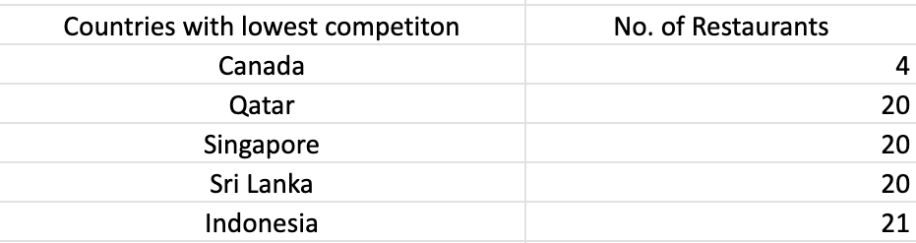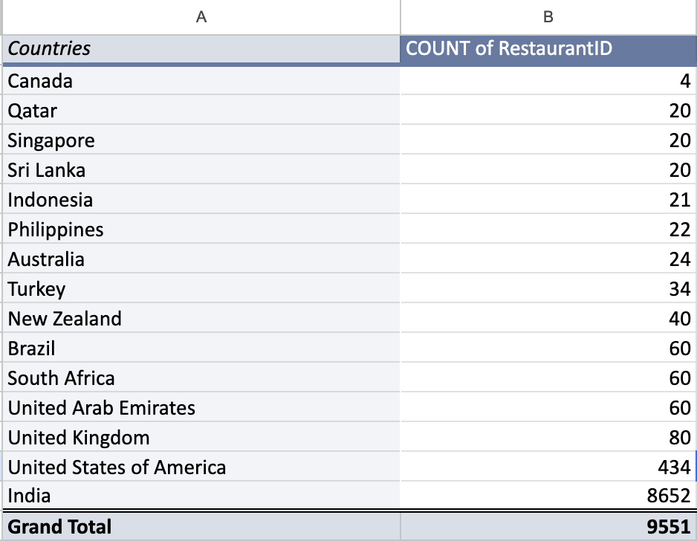

Visualisation:

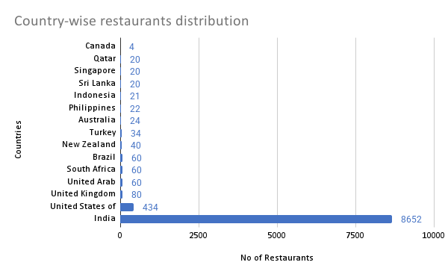

**Avg of rating for each country**

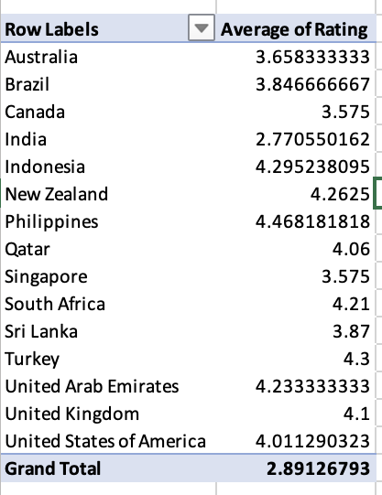

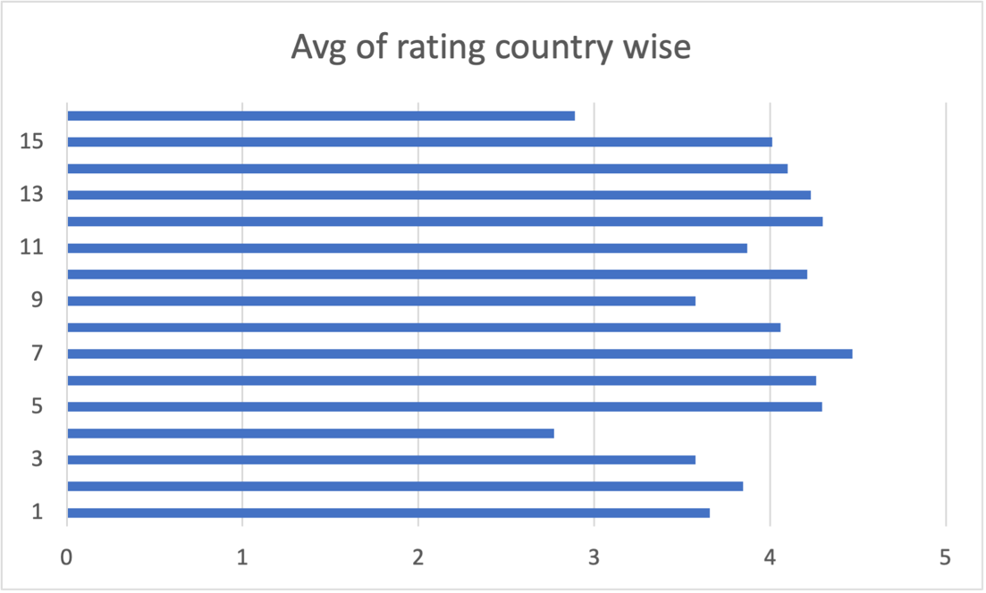

**Insights:**

* Low-Density Markets: Countries like Canada (4), Qatar (20), and Sri Lanka (20), along with Indonesia, Philippines, and Australia, have significantly fewer restaurants, indicating low market competition and high potential for new restaurant ventures.
* Highly Competitive Markets: Countries like India (8,652) and the United States (434) have a high concentration of restaurants, suggesting intense market competition and potential market saturation, making it challenging for new entrants to stand out.
* Countries with fewer existing restaurants are better suited for expansion as they face lower competition thus having better expansion potential.
* Countries with average of two to be considered for better expansion too

**Recommendation:**

* Consider expanding in countries in following extracted countries as they have higher expansion potential, being least competitive:

1. Canada
2. Qatar
3. Singapore
4. Sri Lanka
5. Indonesia

* Pilot with less capital first to check for any variables and avoiding losses.

1. Come up with the names of States and cities in the suggested countries suitable for opening restaurants.

**Approach:**

* Use Pivot Table to aggregate number of restaurants on basis of city.
* Filter out the cities based on the suggested countries identified with least competition.
* Identify cities with least competition. sort the pivot Table in ascending order of no. of restaurants.
* While identifying least competitive cities, make sure to not disregard those cities which are only one in their country with restaurant.
* Visual representation of cities with least competition.

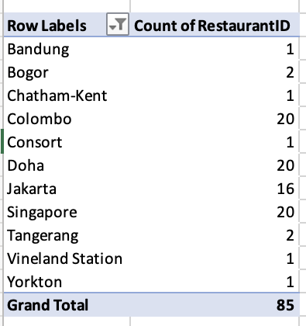

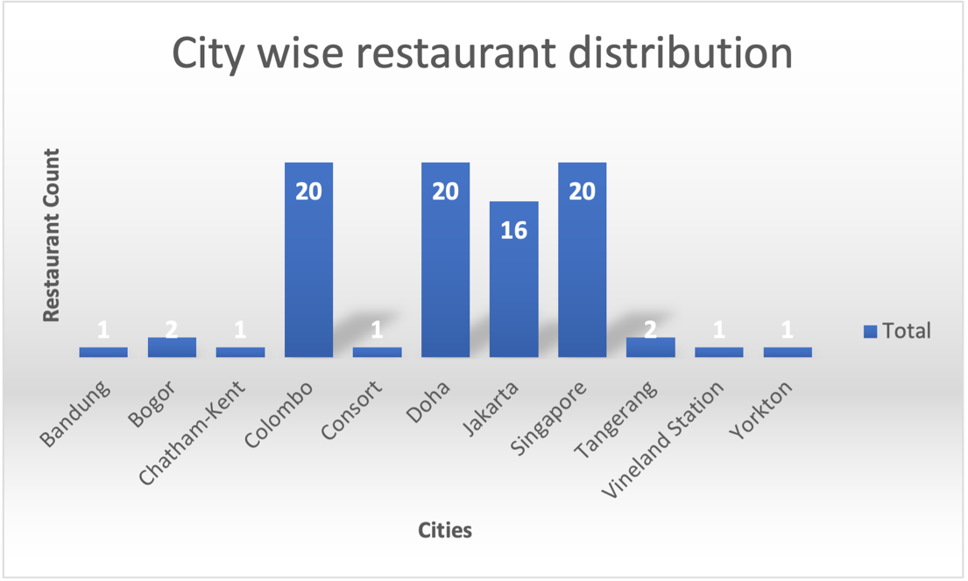

**City-Wise Restaurant Distribution – Analysis Summary**

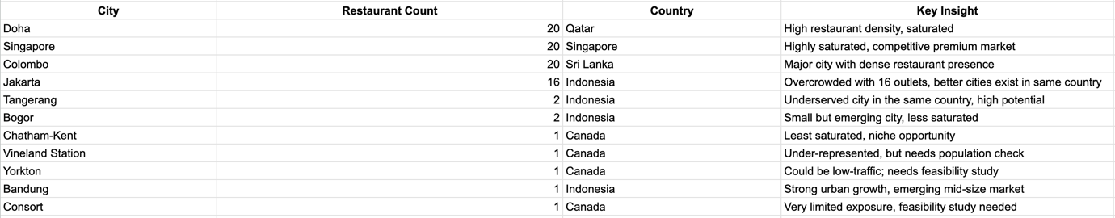

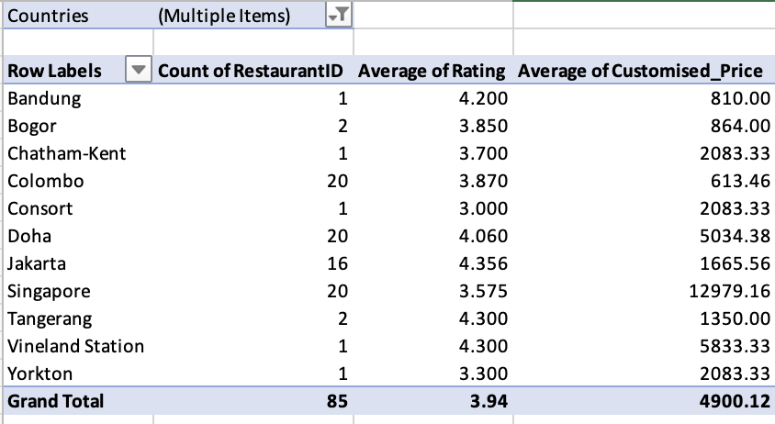

**Insights:**

### **High-Saturation Cities (Avoid for Now):**

* + **Singapore (20), Doha (20), Colombo (20), Jakarta (16)**
  + These cities already host a high number of restaurants and show signs of saturation. Entering these markets would require strong brand differentiation, premium offerings, or niche targeting to succeed.

### **Low-Competition Cities (Opportunity Hubs):**

* + **Bogor (2), Tangerang (2), Bandung (1)** – All in Indonesia, represent emerging urban hubs with limited competition and high ratings (4.2–4.3).
  + **Chatham-Kent (1), Vineland Station (1), Yorkton (1)** – Small cities in Canada with one restaurant each, presenting first-mover advantage.
  + **Consort (1)** – Also in Canada, but rural; low competition yet possibly limited demand. Requires further market analysis.

### **One-City-One-Country Flagship Opportunities:**

* + Cities like **Doha**, **Singapore**, **Colombo** — though saturated — are **key cities in their countries** and may be considered for **brand visibility or flagship presence** if budget allows

**Recommendation:**

### **Expansion Focus Areas:**

* **Indonesia**:
  + Focus on **Tangerang**, **Bogor**, and **Bandung** over Jakarta.
  + These cities are **growing** and offer **low competition entry points**.
  + Test concepts like mid-range dining or family-focused formats.
* **Canada**:
  + Focus on **Chatham-Kent and Vineland Station** for pilot launches.
  + Explore **Yorkton** and keep **Consort** under watch for future rural strategy experimentation.
* **Sri Lanka**:
  + Consider **secondary cities** outside Colombo (if data available) or pilot in Colombo with unique positioning.

1. According to the countries you suggested, what is the current quality regarding ratings for restaurants that are open there?

**Approach:**

* Use Pivot Table to calculate average rating for countries.
* Filter restaurant ratings for suggested countries(least competitive countries).
* Use clustered column chart, we could easily compare the location based ratings of least competitive states globally.

**Screenshot -  
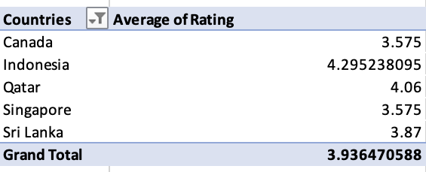**

**Insights:**

* High-Rated Countries:
* Indonesia (4.29), Qatar (4.06), and Sri Lanka (3.87) demonstrate strong customer satisfaction, indicating high service quality and good dining experiences.
* Lower Rated Countries:
* Canada (3.575) and Singapore (3.575) show average or poor customer satisfaction, suggesting inconsistencies in service or food quality.

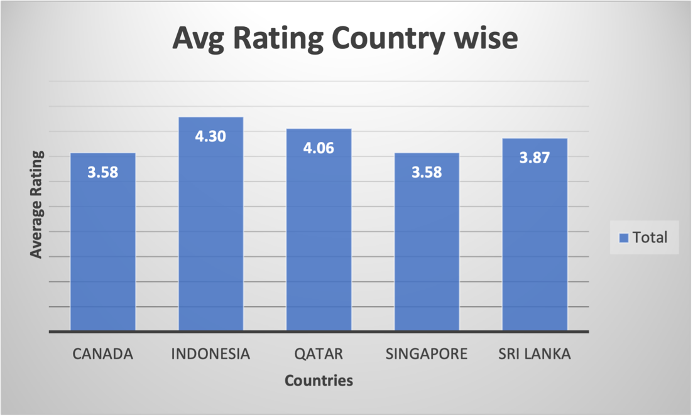

**Recommendations:**

* For High-Rated Countries:
* Leverage positive ratings for tourism marketing, promoting these countries as premium dining destinations.
* Maintain service and food quality to sustain high customer satisfaction.
* For Lower Rated Countries:
  + Focus on improving service consistency and food quality to enhance customer experience.
  + Analyze customer feedback to identify and address recurring issues.

1. Also, what is the current expenditure on food in the suggested countries, so we can keep our financial expenditure in control?

**Approach -** Filtered the pivot table for suggested countries and added sum of customised_price in values then created the column chart for displaying Average Food expenditure in suggested countries.

**Screenshot –**

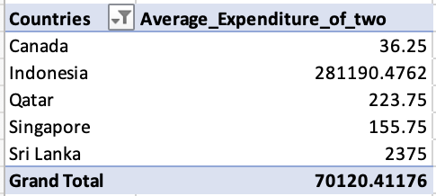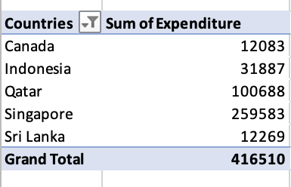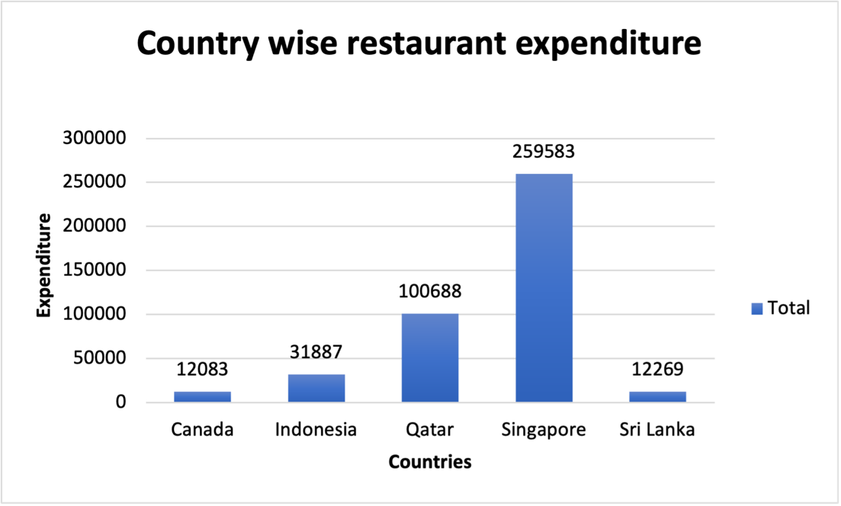

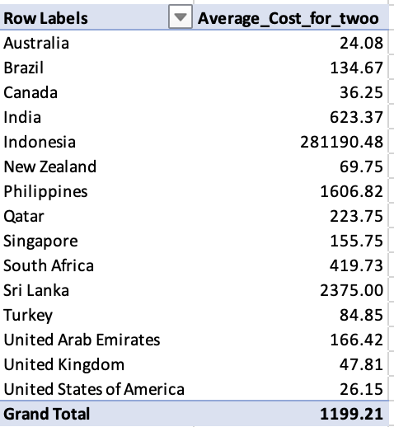

**Insights:**

* Singapore (2,59,583) and Qatar (1,00,688) have the highest restaurant expenditures, indicating high spending power and demand for premium dining experiences.
* Indonesia (31,887) and Sri Lanka (12,269) show moderate spending, suggesting potential for growth in mid-range dining options.
* Canada (12,083) has an extremely low expenditure, possibly indicating a lack of restaurant market presence or data collection gaps.

**Recommendations:**

* Menu and pricing strategy: Singapore and Qatar show high spending potential, making them ideal targets for luxury and fine-dining investments.
* Optimize Expansion Budget: Indonesia and Sri Lanka could benefit from affordable dining options and marketing strategies to boost spending.

1. Come up with the names of restaurants from the recommended states that are our biggest competitors and also those that are rated in the lower brackets, i.e. 1-2 or 2-3.

**Approach:**

* Use a pivot table to calculate average rating of every restaurant.
* Filter the restaurants by suggested cities
* Sort them in descending order by Avg. Rating to find biggest competitor.

**Insights:**

* High-Rated Competitors:

Ministry of Crab, Talaga Sampireun, Mainland China Restaurant are our biggest competitors indicated by their highest rating of 4.9 and dominate the premium restaurant space.

* Low rated restaurants:

Queen's Café rated with 2.5 and Elite Indian Restaurant rated with 2.4 are among most poor rated restaurants in suggestive cities, indicating a potential opportunity to introduce high-quality options.

* Majority of Restaurants Have Ratings Between 3.5 and 4.2: Most restaurants fall within the 3.5 to 4.2 rating range, suggesting that while they offer decent quality, they may lack the unique qualities needed to achieve ratings above 4.5.

Pivot table: Restaurants with rating under “3”

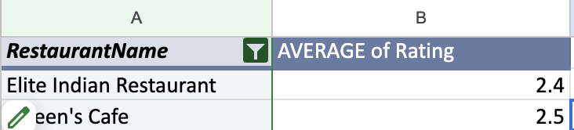

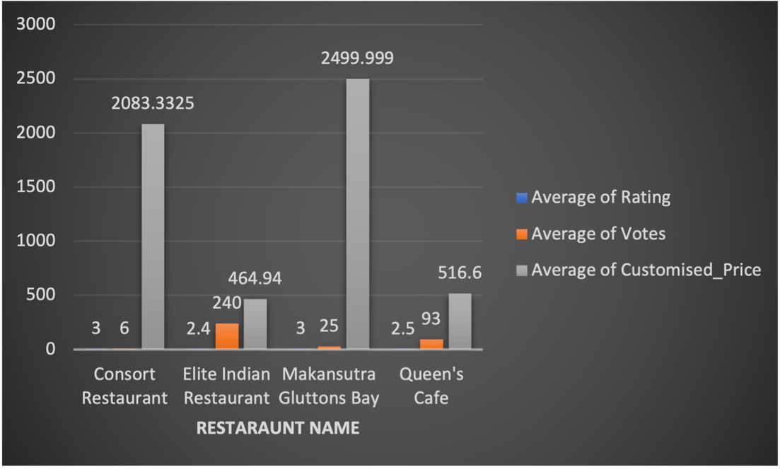

**Analysis of Restaurant Ratings in Selected Countries  
Average rating per restaurant for selected countries**

**High-Rated Competitors (Top Tier)**



**Low-Rated Restaurants (Rating 1.0–3.0)**



**Recommendations:**

* Low rated restaurants (Queen’s Café,Elite Indian Restaurant) should prioritize improving menu offerings, customer experience, and staff training to elevate their ratings.
* Establishments within 3.5-4.2 range should introduce unique dishes, enhance ambiance, or offer special promotions to improve their rankings and compete with top-tier competitors.
* **New Market Entry Strategy:**
  + - Position your restaurant as **quality-first** with unique offerings and modern service.
    - Target cities with **low-rated competitors and mid-performing clusters**, like **Colombo (Sri Lanka)**, **Ankara/Istanbul (Turkey)**, **Bogor (Indonesia)**.
* **For Mid-Rated Restaurants (3.5 – 4.2):**
  + - Introduce **signature dishes or chef specials**
    - Improve **visual branding** and **ambiance themes**
    - Offer **seasonal promotions** or **loyalty programs** to build repeat customer base
* For Low-Rated Restaurants:
  + - **Focus Areas**: Menu revamp, staff training, customer service, ambiance improvements
    - Consider feedback loops (reviews/comments) to drive changes
    - Leverage local culture with quality fusion options

1. Which cuisines should we focus on in the newer restaurants to get better feedback? Does the choice of cuisines affect the restaurant ratings?

**Approach -** Taken cuisines_imputed in rows and average rating in values then done descending order of cuisines based on average rating to lsit the ratings from high to low.  
 **Screenshot -**

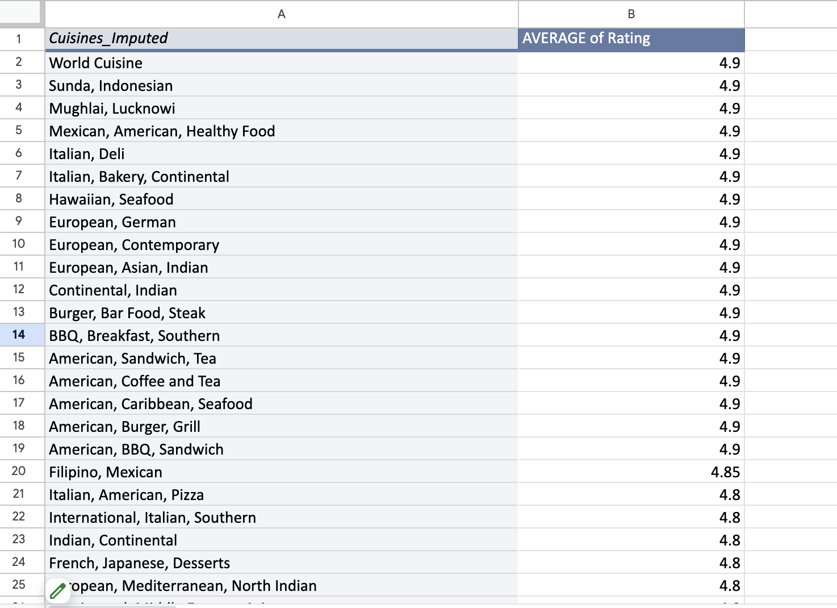

**Insights**

Cuisines impact restaurant ratings significantly. Restaurants serving these cuisines tend to receive higher ratings, suggesting customer preferences for diverse and global flavors.

**Recommendations**

**Cuisines focus on newer restaurants**

World Cuisine, Pizza, Continental, Indian,Sushi, Japanese,Seafood,Desserts, Ice Cream

1. According to our current data, should we go for online delivery and table booking? Does that affect the customer’s ratings?

**Approach -** Create Pivot table taking has_table_booking in rows and has_online_delivery in columns and average of rating in values. Based on this data created column chart to display which has high rating.

**Screenshot -**

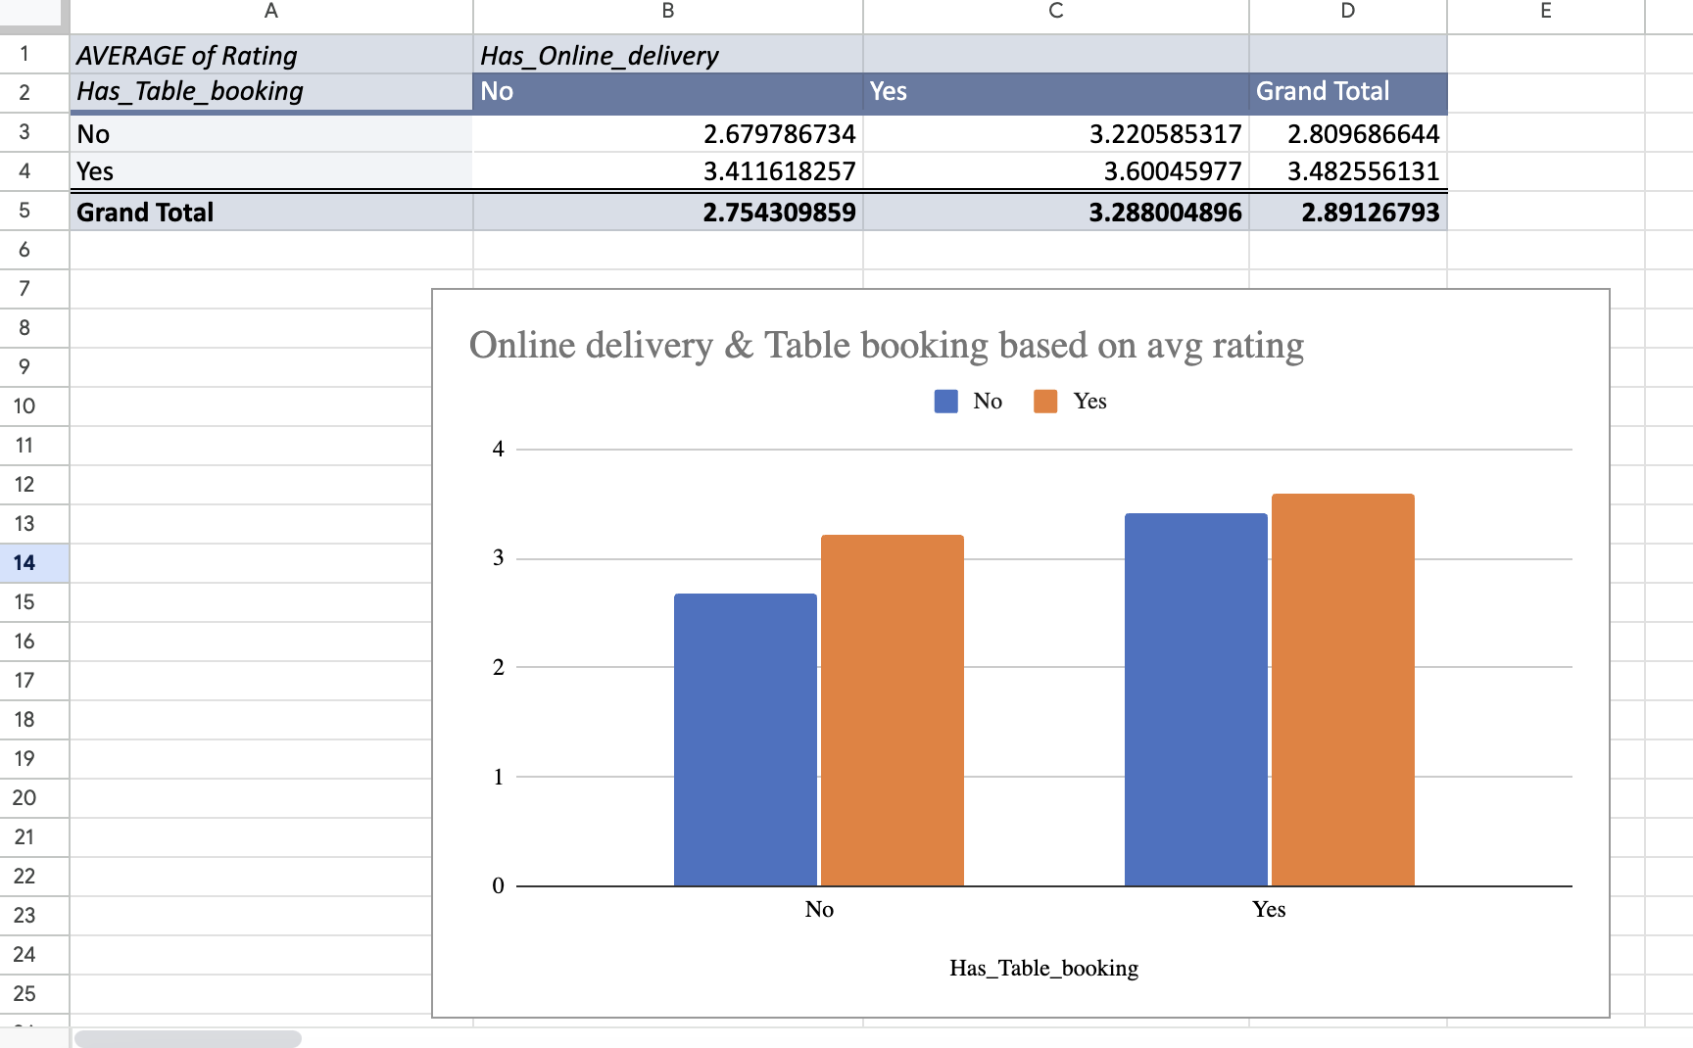

**According to this data, will suggest go for table bookings.**

**Insight:**

Restaurants offering online delivery have an average rating of 3.288, compared to 2.754 for those without. Similarly, restaurants with table booking have a higher average rating of 3.482 compared to 2.809 without it. This indicates that providing these services significantly enhances customer satisfaction.

**Recommendation:**

* Implement Online Delivery and Table Booking: Expand these services across all locations to boost customer ratings and satisfaction.
* Enhance Service Experience: Focus on delivering a seamless user experience through efficient delivery systems, easy booking processes, and high-quality service to maximize positive customer feedback.

1. Should the team keep the rate of cuisines higher? Will that affect the feedback? According to our data are the rates of cuisines and ratings, correlated?

**Approach -** Create Pivot table taking cuisines_imputed in rows and average rating, avg for cost for two in values. Created corelation between rating and price.

**Screenshot -**

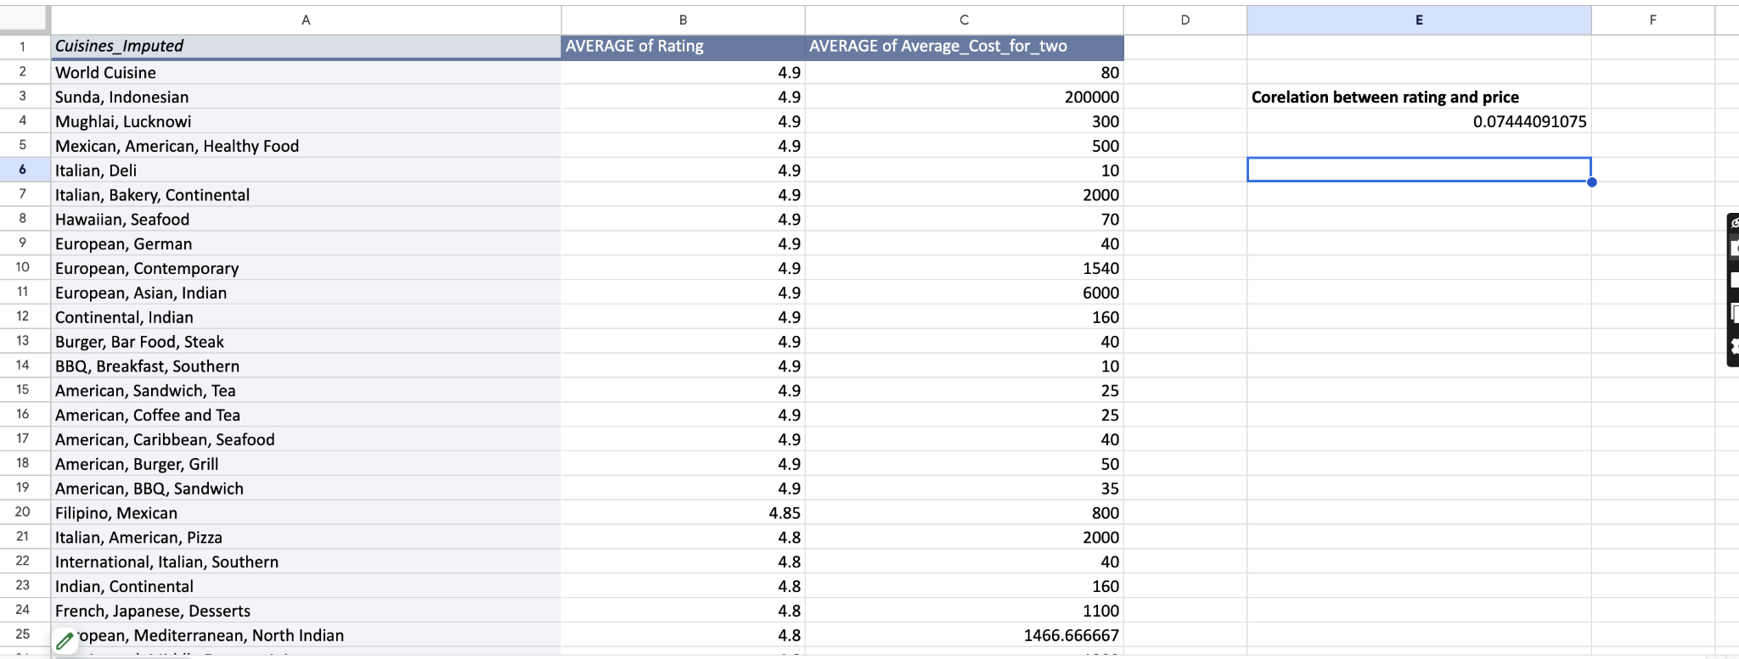

**Insight:**

A correlation of 0.07 indicates almost no relationship between cuisine pricing and customer ratings. This suggests that price adjustments have minimal impact on customer feedback, as ratings are driven more by service quality and dining experience rather than pricing.

**Recommendation -**The correlation value is **0.07**, which indicates a **weak positive correlation** between **higher prices and better ratings.**

1. What is the distribution of the number of restaurants of different price ranges in all the countries?

**Approach:**

Use a pivot table to group restaurants by price range and country.

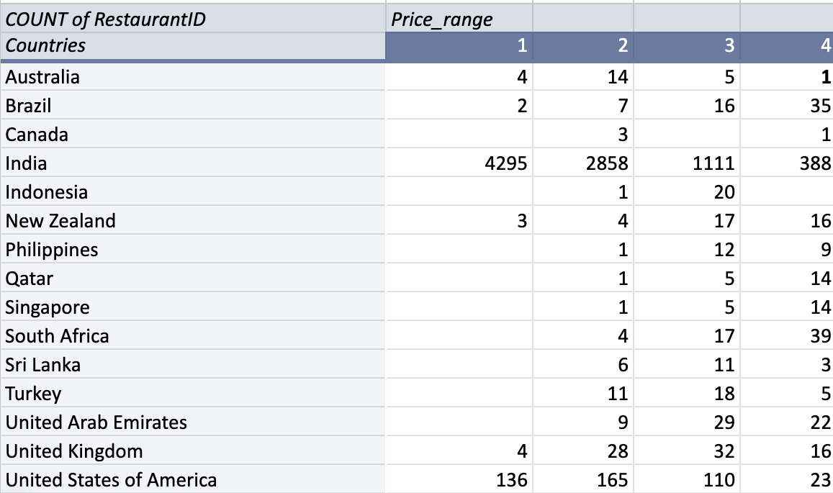

Visualisation:  
  
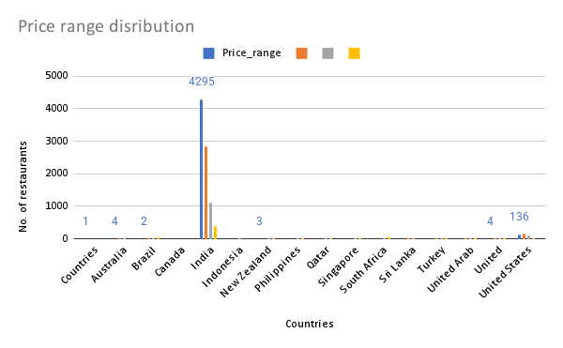

**Insights:**

* India dominates the restaurant landscape, with a majority of outlets falling under lower price ranges (1 & 2), reflecting a strong demand for affordable dining options.
* In developed countries such as the U.S., U.K., and Australia, there is a balanced distribution across all price ranges, indicating diverse consumer preferences for both budget-friendly and premium dining experiences.
* Premium dining markets are more prominent in Brazil and South Africa, where a higher number of upscale restaurants (Price Range 4) suggests a strong appetite for fine dining.
* Limited market size is observed in countries like Canada and Indonesia, where the restaurant count remains comparatively low, presenting potential for market expansion.

**Recommendations:**

* Target budget-conscious customers in India and other high-demand markets by expanding affordable dining options, catering to price-sensitive consumers.
* In developed countries, such as the U.S., U.K., and Australia, adopt a balanced approach by offering both casual and premium dining experiences to address varied customer preferences.
* Capitalize on high-end dining demand in markets like Brazil, South Africa, and Qatar by expanding fine-dining establishments, leveraging the existing appetite for premium experiences.

1. Explain your approach in brief for suggesting countries/cities in order to open new restaurants, if the objective and subjective questions would have not been given to assist you. **[you have to give bullet pointers in order to answer this question]**
   * Identify countries with fewer existing restaurants (low competition).
   * Analyze population density & urbanization – higher demand in metro areas.
   * Check GDP per capita & income levels – affordability of dining out.
   * Analyze popular cuisines in different regions.
   * Check restaurant ratings & reviews to understand customer preferences.
   * Identify growth trends in the food industry (rising demand for fast food, vegan, etc.).
   * Identify top competitors and their locations.
   * Check areas with lower-rated restaurants → potential for better service & food quality.
   * Evaluate presence of major restaurant chains (saturation risk).
   * Compare real estate & operational costs in different cities.
   * Analyze food expenditure trends to estimate market spending.
   * Evaluate labor costs & availability for efficient staffing.